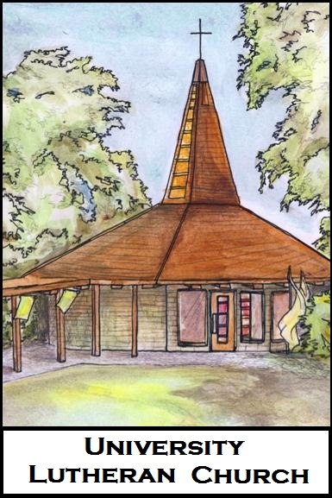
University Lutheran Church

Funeral Planning Form

At a person’s death, the church shares the grief of those who mourn and remembers the brevity of life on earth. At the funeral, we give voice to sorrow, thank God for our loved one, and entrust our companion into the hands of God.
As we begin to plan this Funeral Service, we’ll use this form as an aid. You can attach additional pages in response to these questions.

First, some basic personal information
Full Name: (Nickname, if any: )
Date and Place of Birth:
Date and Place of Baptism:
Date and Place of Death:
Relationship to University Lutheran Church (member, former member, friend, neighbor, etc.):

Family information
Parents:
Siblings:
Spouse/Partner (and number of years together):
Children:
Grandchildren:
Other significant persons:

Memories and Stories:
How would you describe your loved one?

Are there any stories you want to share?

What did he/she most love to do?

What mattered to him/her?

What will you miss most?

Specifics about the service:
Will it be a funeral (with the deceased present in casket or urn?) or a memorial service (no physical presence)?
Should Holy Communion be part of this service? (The default is to include communion.)
Would you like the choir to sing?
Is there a specific presiding minister, preaching minister, and/or music minister you would like to request?

Did your loved one make any special requests?

What Bible passages, prayers, or other writings would you like to have included in the service? Why are they meaningful?

Are there hymns or songs that have been especially meaningful to you or to the deceased? In what way?

Do you have any particular wishes concerning congregational singing, vocal/instrumental solos, or soloists?

Are there people (family, friends, members of the congregation or community) who should be involved in some way (reading the lessons, delivering the eulogy, serve as pall bearers, serving communion, etc)?

Do you want to distribute a written obituary/biography to the congregation at the service? Will you write this yourself? (Think about what personal information [birth date/place, parents’ names, marriage date, names of spouse/children, education, occupation, military service, church service, community service, civic service] and faith information [dates of baptism, confirmation, ordination] should be included, as well as anything else [burial wishes, donation preferences, reception, etc.] you would like noted.)
Immediately after the service
Do you plan to have refreshments after the service, and can UniLu help coordinate this?

Will the reception include a slide show or a photo display?

Will the reception include time for people to share memories? (For several reasons, our custom is to have one eulogy during the service and have other people share memories at the reception afterward.)

If this will be a funeral, will burial immediately follow the funeral service? If so, where? Is everyone invited?

Do you have arrangements with a funeral home? If so, which one?

Other considerations
Who will be the primary contact person beforehand and on the day of the service? That is, whom should Pastor talk to with questions about the service itself? ______________________________________________
As you invite people to the service, please encourage people to carpool; parking is limited and cars might have to park on the street.
If people want to send flowers to the service, they can send them to 1611 Stanford Ave, Palo Alto, CA 94306.
Please make a list “We can’t start until _____ gets here” list for the day of the service, in case there is traffic.
Pastor will follow up with you regularly, before and after the service, but please don’t hesitate to contact him with any questions, concerns, needs, or pastoral care situations that arise.

For Office Use Only
Date of Service:
Time of Service:
Expected attendance:
Rooms needed:
Presider:
Preacher:
Musician:
Reception Coordinator:
Parking Permits:
Funeral Home:

